1. Write a paragraph describing what issues you encountered in this tutorial and how you overcame them.

While creating the spring API I ran into this error. I[ssue With Spring: There was an unexpected error (type=Not Found, status=404)](https://stackoverflow.com/questions/36819277/issue-with-spring-there-was-an-unexpected-error-type-not-found-status-404). I found that I needed to add a @componentScan. After that I was able to get it to work correctly. Another issue I have found is that I am not really sure how to use the postman app and how I need to input data and stuff.

1. Write another paragraph about what you learned.

I learned how to create a local host API. I also learned that I really need to work on trying to figure out what I need to google. Once I have decided what I need to google I need to get good a googling and deciphering what I am reading to salve me errors. I definitely need to work on my patients and remember to google!

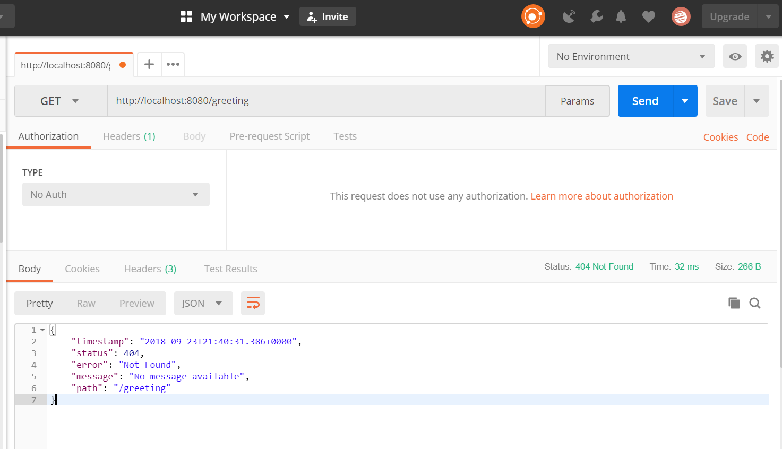

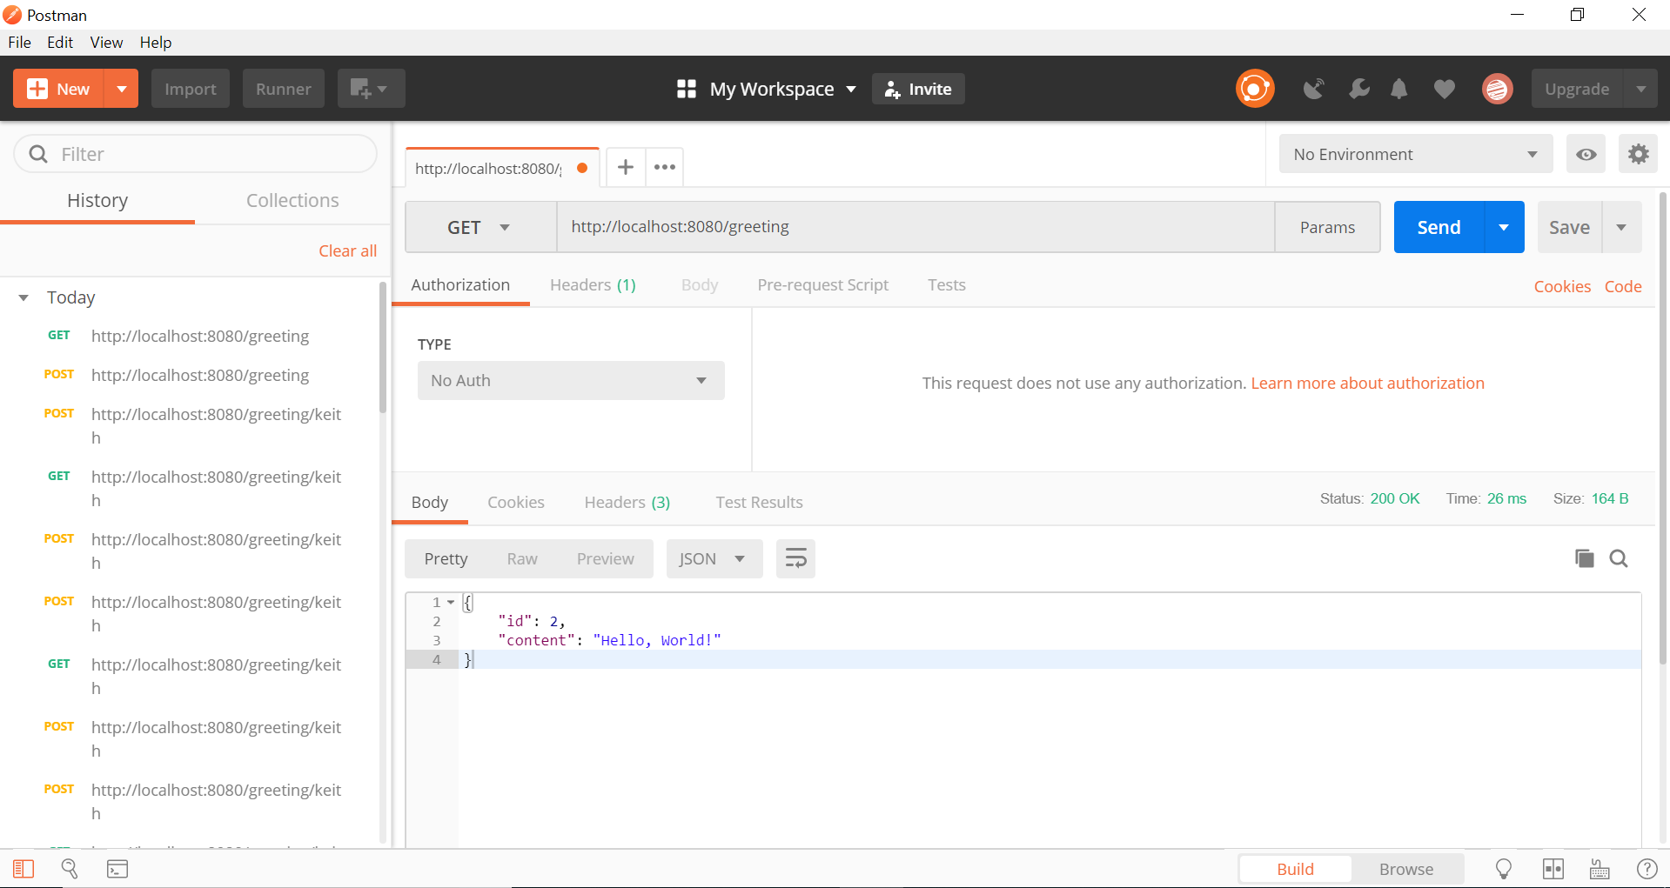

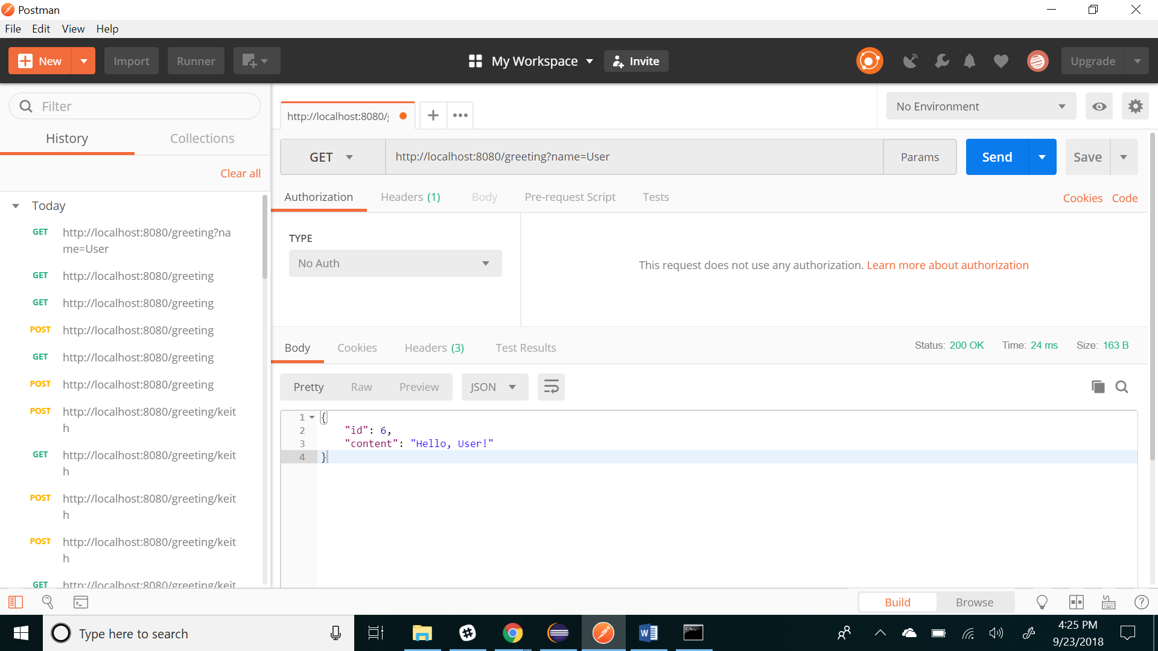

Based on the link provide in the homework I think I read that you can only run 2 requests with the code that is written in the text. So, I provide a picture of the error that I got which showed me what I needed to google.